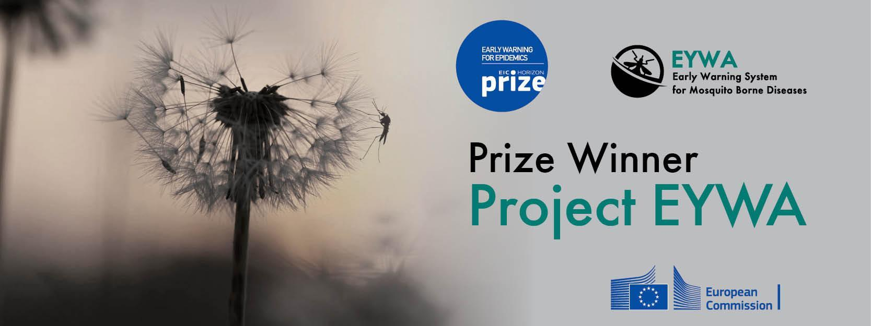

**Veneto and Trentino Regions, Italy**

Report period 01/10/2024 - 31/10/2024

**EYWA** (EarlY WArning System for Mosquito-Borne Diseases), a prototype operational system since 2020, addressing the critical public health need for prevention and protection against the Mosquito-Borne Diseases (MBDs).

A game changer in the domain of epidemics that lies under the umbrella of **EuroGEO Action Group** "Earth Observation for Epidemics of Vector-borne Diseases - EO4EViDence"

This monthly Report is produced by the EYWA Project with key contribution in data and scientific expertise from its collaborating partners Istituto Zooprofilattico Sperimentale delle Venezie (IZSVe), Edmund Mach Foundation (FEM) and University of Trento/Department of Mathematics.

**Contents**

**INTRODUCTION** **4**

**PREDICTIVE MODELS** **6**

**1. MAMOTH – Mosquitoes’ Abundance model** **6**

I. Veneto region………………………………………………………………………………..6

A. *Culex* mosquitoes’ abundance prediction 6

B. *Anopheles* mosquitoes’ abundance prediction 8

II. Trentino region……………………………………………………………………………10

A. *Culex* mosquitoes’ abundance prediction 10

B. *Anopheles* mosquitoes’ abundance prediction 12

C. *A**edes Albopictus* mosquitoes’ abundance prediction 14

**2. MIMESIS – HUMAN CASES RISK MODEL 15**

# Introduction

More than 80% of the global population lives in areas at risk of at least one major Vector-Borne Disease (VBD), with more than 700.000 deaths at a global scale. Mosquitoes are the protagonists of these vectors, carrying pathogens and transmitting various diseases to living beings and especially humans. Although specific actions and practices were adopted to control these diseases in Europe in the past decades, the re-emergence of outbreaks is just around the corner. Europe is experiencing an increasing number of human cases of Mosquito-Borne Diseases (MBD) in the last two decades, such as West Nile Virus (WVN), Malaria, Chikungunya, Dengue and Zika, both imported and indigenous, which demonstrates that Europe is not immune from MBD.

Italy experienced the first outbreak of WNV in 1998, in horses in Tuscany region, without the occurrence of human cases. Ten years later the WNV lineage 1 re-emerged in the Po River Delta of North-eastern Italy. Then, in 2011, it was completely replaced by WNV lineage 2, following the outbreak in Greece in 2010. In particular, Veneto region is the only region of Italy that is reporting evidence of WNV circulation, either in animals, mosquitoes and/or humans continuously since 2008. This suggests that WNV has been established in Italy, as well as in other European countries. Consequently, the recurrence of WNV infection cases in the country is considered likely and expected in each transmission period, during the mosquito circulation season.

*Table 1.* WNV infection cases in Italy over the years 2010-2023 (source: ECDC).

|  |  |  |  |  |  |  |  |  |  |  |  |  |  |  |
| --- | --- | --- | --- | --- | --- | --- | --- | --- | --- | --- | --- | --- | --- | --- |
| Year | 2010 | 2011 | 2012 | 2013 | 2014 | 2015 | 2016 | 2017 | 2018 | 2019 | 2020 | 2021 | 2022 | 2023 |
| WNV infection cases | 11 | 32 | 73 | 160 | 24 | 62 | 81 | 54 | 618 | 55 | 66 | 55 | 586 | 336 |

Italy was declared free of malaria by the World Health Organization in 1970. However, the *Anopheles* mosquitoes that transmit malaria are present and were the main vectors for Malaria transmission in the north-eastern coast of Italy, where Veneto is located.

*Table 2. Malaria reported cases in Italy over the years 2008-2022 (source: ECDC).*

|  |  |  |  |  |  |  |  |  |  |  |  |  |  |  |  |
| --- | --- | --- | --- | --- | --- | --- | --- | --- | --- | --- | --- | --- | --- | --- | --- |
| Year | 2008 | 2009 | 2010 | 2011 | 2012 | 2013 | 2014 | 2015 | 2016 | 2017 | 2018 | 2019 | 2020 | 2021 | 2022 |
| Malaria reported cases | 583 | 636 | 698 | 701 | 642 | 677 | 705 | 706 | 888 | 830 | 722 | 792 | 181 | 443 | 571 |

EYWA is an innovative, scalable and sustainable EarlY WArning System for Mosquito-Borne Diseases and a game changer in the domain of epidemics. It was developed under the flag of EuroGEO Action Group “Earth Observation for Epidemics of Vector-Borne Diseases-EO4EViDence".

The system is based on a plethora of satellite Earth Observation (environmental, meteorological, geomorphological etc.), in-situ entomological networks, epidemiological and crowdsourcing data. These Big Data are combined with mathematical modelling, artificial intelligence, and state-of-the-art technological tools. The system’s models provide monthly mosquitoes’ population and human cases risk predictions, at trap and region level accordingly.

In recognition of the advances made by the system in providing early warning, EYWA was awarded the [1st EIC Horizon Prize on Early Warning for Epidemics](http://beyond-eocenter.eu/images/eywa/prize-material/EYWA_Prize_Press_Release_ENG.pdf).

EYWA has operated successfully with a demonstrated impact in Veneto region in Italy, forecasting *Culex* mosquito populations and West Nile Virus outbreaks, during the mosquito seasons in 2020, 2021, 2022 & 2023.

EYWA continues its operation in 2024, informing the local authorities and decision makers about *Culex* and *Anopheles* mosquitoes’ abundance at the traps sites, and WNV human cases risk at Veneto’s provinces.

# Predictive models

The results of the “MAMOTH” data-driven mosquitoes’ abundance model for the period **08/10/2024 – 23/10/2024**, and of the “MIMESIS” dynamic human cases risk model for the period **25/09/2024 – 25/10/2024**, are presented in the following sections.

## 1. MAMOTH – Mosquitoes’ Abundance model

The “MAMOTH” data-driven mosquitoes’ abundance predictive model has been in operational use since 2020. The model is able to predict the risk classes of mosquitoes’ population.

For each entomological record, the respective EO environmental and meteorological data (NDVI, NDWI, NDMI, NDBI, Land Surface Temperature, rainfall and wind), and geomorphological data (land use, aspect, elevation etc.) have been extracted from Sentinel-2, Landsat-7 & -8, MODIS, and ERA-5 to create the comprehensive feature space.

The abundance of the mosquitoes has been classified into 10 risk classes starting from 0 indicating the lower class of mosquito presence reaching the higher class 9, with each one having equal probability of selection. A XGBoost is trained for this task, and a certain pipeline is followed. The multi-source dataset mentioned above, underwent spatial and temporal integration, as well as feature engineering that has been applied to further extend the initial dataset through new informative features that capture the spatio-temporal dependencies of the problem. Through an automated process the model can tune its own parameters and select the most important features out of a pool of potential features in each case in order to better fit the dataset, and achieve higher prediction performance.

### I. Veneto Region

#### A. *Culex* mosquitoes’ abundance prediction

The forecast model is based on time series entomological data for the period of 2010-2023. The dataset has been gathered from CO2 and gravid traps, which were used to lure and sample adult mosquitoes from 187 stations distributed among the Veneto region. The data consist of 8258 records and represent the number of mosquitoes, the date of trap placement, date of trap removal and the number of positive to WNV mosquitoes.

#### Risk classes

Table 3 shows the classes of the mosquito abundance and the bounds (range) of mosquito’ numbers per each class. Furthermore, Table 3 displays the occurrence’s probability of at least one mosquito positive to WNV per class.

*Table 3: Bounds of Culex mosquito risk classes & occurrence probability of at least one mosquito positive to WNV.*

|  |  |  |  |
| --- | --- | --- | --- |
| Class | Number of mosquitoes | Probability of at least one mosquito positive to WNV | Risk class |
| 0 | 0 - 3 | 0.23 % | low |
| 1 | 4 - 8 |
| 2 | 9 - 17 | 1.07 % | medium |
| 3 | 18 - 30 |
| 4 | 31 - 50 | 2.82 % |
| 5 | 51 - 83 |
| 6 | 84 – 143 | 6.35 % | high |
| 7 | 144 - 254 |
| 8 | 255 - 509 | 8.01 % |
| 9 | > 509 |

#### Reliability of the model

The model has been trained on historical data for the period of 2010 to 2023. The trained model outperforms statistically with an expected mean absolute error of **1.14** classes between the actual and the predictive value. Furthermore, the model proves its robustness by capturing the low, medium and high-risk classes of mosquito population with a predictive accuracy of **96%**.

#### Prediction

The predictions of the model are presented in the map of Figure 1, which depicts the predicted trap – stations for October 2024 in the Veneto region ranging from traps colored in blue, stations that the model predicts lower risk class of the *Culex* population, to traps colored in red indicating stations with prediction of higher risk class in mosquito abundance. The predictions for October showed that the stations in the Veneto region will fall into **the low & medium risk classes** ranging from risk class 0 to risk class 4. In further detail:

* 5405 stations were predicted with risk classes 0 & 1 indicating low abundance of mosquitoes (0 – 8).
* 1175 stations were predicted with risk classes from 2-4 indicating medium abundance of mosquitoes (9 – 50).

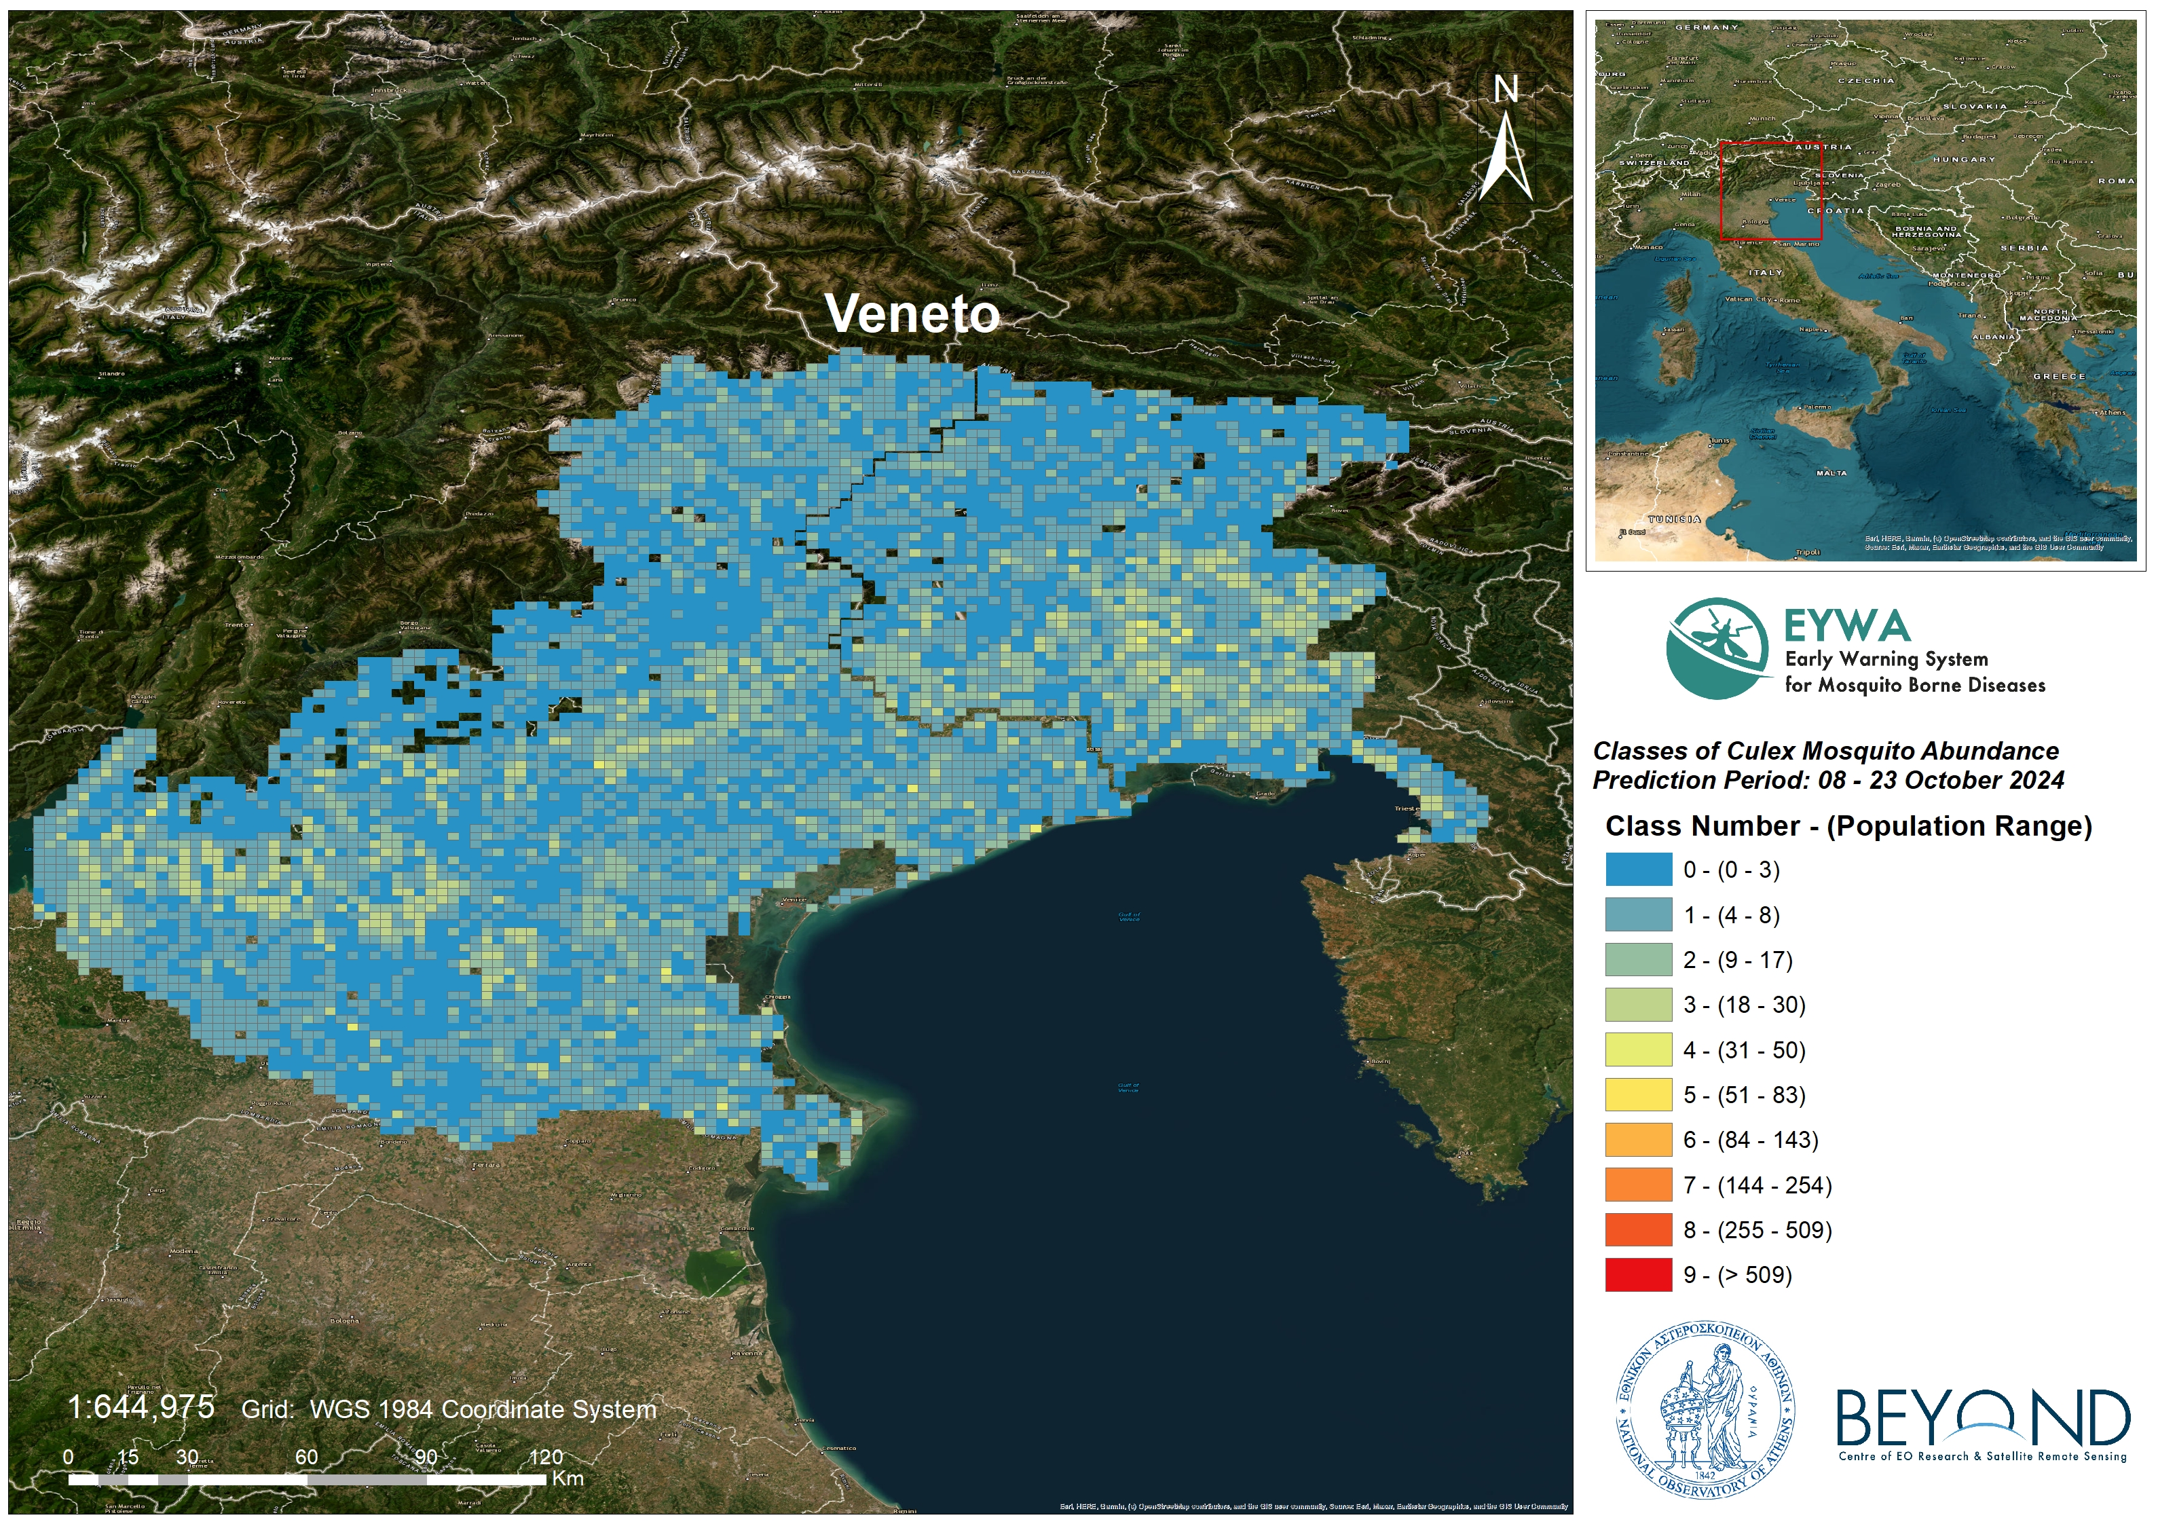*Figure 1: Culex mosquito abundance at 2x2 km grid in Veneto for October 2024.*

#### B. *Anopheles* mosquitoes’ abundance prediction

The forecast model is based on time series entomological data for the period of 2010-2023. The dataset has been gathered from CO2 and gravid traps, there were used to lure and sample adult mosquitoes from 187 stations distributed among the Veneto region. The data consist of 2500 records and represent the number of mosquitoes and the date of trap placement.

#### Risk classes

Table 4 shows the classes of the anopheles mosquito abundance and the bounds (range) of mosquito’ numbers per each class.

*Table 4: Bounds of Anopheles mosquito abundance classes*

|  |  |  |
| --- | --- | --- |
| Class | Number of mosquitoes | Risk class |
| 0 | 1 - 2 | low |
| 1 | 3 -16 |
| 2 | 17 – 48 | medium |
| 3 | 49 – 98 |
| 4 | 99 – 195 |
| 5 | 196 – 318 |
| 6 | 319 – 500 | high |
| 7 | 501 - 772 |
| 8 | 773 -1300 |
| 9 | > 1300 |

#### Reliability of the model

The model has been trained and tested on 10-fold validation data. The trained model outperforms statistically with an expected mean absolute error of **1.11** classes between the actual and the predictive value. Furthermore, the model proves its robustness by capturing the low, medium and high-risk classes of mosquito population with a predictive accuracy of **98%.**

#### Prediction

The predictions of the model are presented in the map of , which depicts the predicted trap – stations for October 2024 in the Veneto region ranging from traps colored in blue, stations that the model predicts lower risk class of the *Anopheles* population, to traps colored in red indicating stations with prediction of higher risk class in mosquito abundance. The predictions for October 2024 showed that the stations in the Veneto region will fall into **the low & medium risk classes** ranging from risk class 0 to risk class 2. In further detail:

* 6579 stations were predicted with risk classes 0 & 1 indicating low abundance of mosquitoes (1-16).
* 1 station was predicted with risk class 2 indicating medium abundance of mosquitoes (17-48).

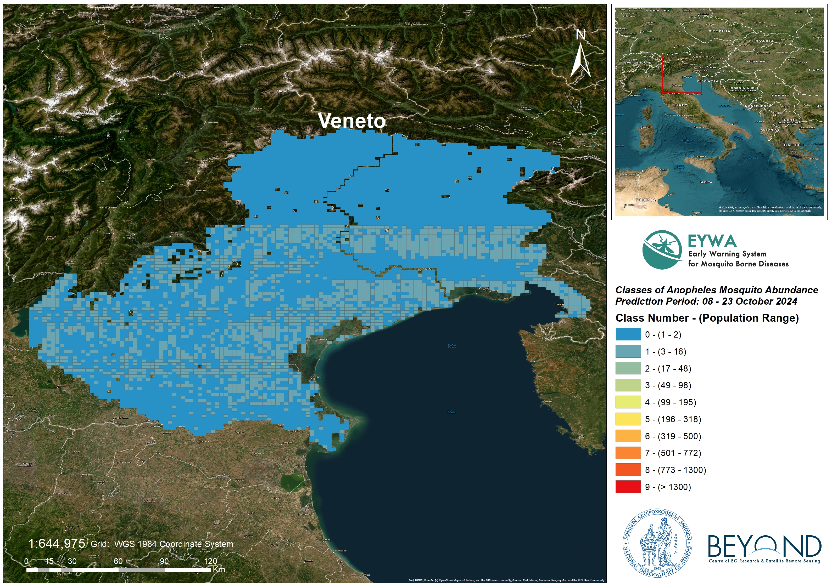

*Figure 2: Anopheles mosquito abundance at 2x2 km grid in Veneto for October 2024.*

### II. Trentino Region

#### A. *Culex* mosquitoes’ abundance prediction

The forecast model is based on time series entomological data for the period of 2011-2023. The dataset has been gathered from BG-Sentinel traps, which were used to lure and sample adult mosquitoes from 13 stations distributed among the Trentino region. The data consist of 3738 records and represent the number of mosquitoes, the date of trap placement, date of trap removal and the number of positive to WNV mosquitoes.

#### Risk classes

Table 5 shows the classes of the mosquito abundance and the bounds (range) of mosquito’ numbers per each class.

*Table 5: Bounds of Culex mosquito risk classes.*

|  |  |  |
| --- | --- | --- |
| Class | Number of mosquitoes | Risk class |
| 0 | 0 - 1 | low |
| 1 | 2 |
| 2 | 3 | medium |
| 3 | 4 - 5 |
| 4 | 6 - 8 |
| 5 | 9 – 11 |
| 6 | 12 - 14 | high |
| 7 | 15 - 23 |
| 8 | 24 - 30 |
| 9 | > 30 |

#### Reliability of the model

The model has been trained on historical data for the period of 2011 to 2023. The trained model outperforms statistically with an expected mean absolute error of **0.60** classes between the actual and the predictive value. Furthermore, the model proves its robustness by capturing the low, medium and high-risk classes of mosquito population with a predictive accuracy of **96%**.

#### Prediction

The predictions of the model are presented in the map of Figure 3, which depicts the predicted trap – stations for October 2024 in the Trentino region ranging from traps colored in blue, stations that the model predicts lower risk class of the *Culex* population, to traps colored in red indicating stations with prediction of higher risk class in mosquito abundance. The predictions for October 2024 showed that the stations in the Trentino region will fall into **the low, medium & high risk classes** ranging from risk class 0 to risk class 7. In further detail:

* 129 stations were predicted with risk classes 0 & 1 indicating low abundance of mosquitoes (0-2).
* 1504 station was predicted with risk class 2 - 5 indicating medium abundance of mosquitoes (3-11).
* 333 stations were predicted with risk class 6 & 7 indicating high abundance of mosquitoes (12-23).

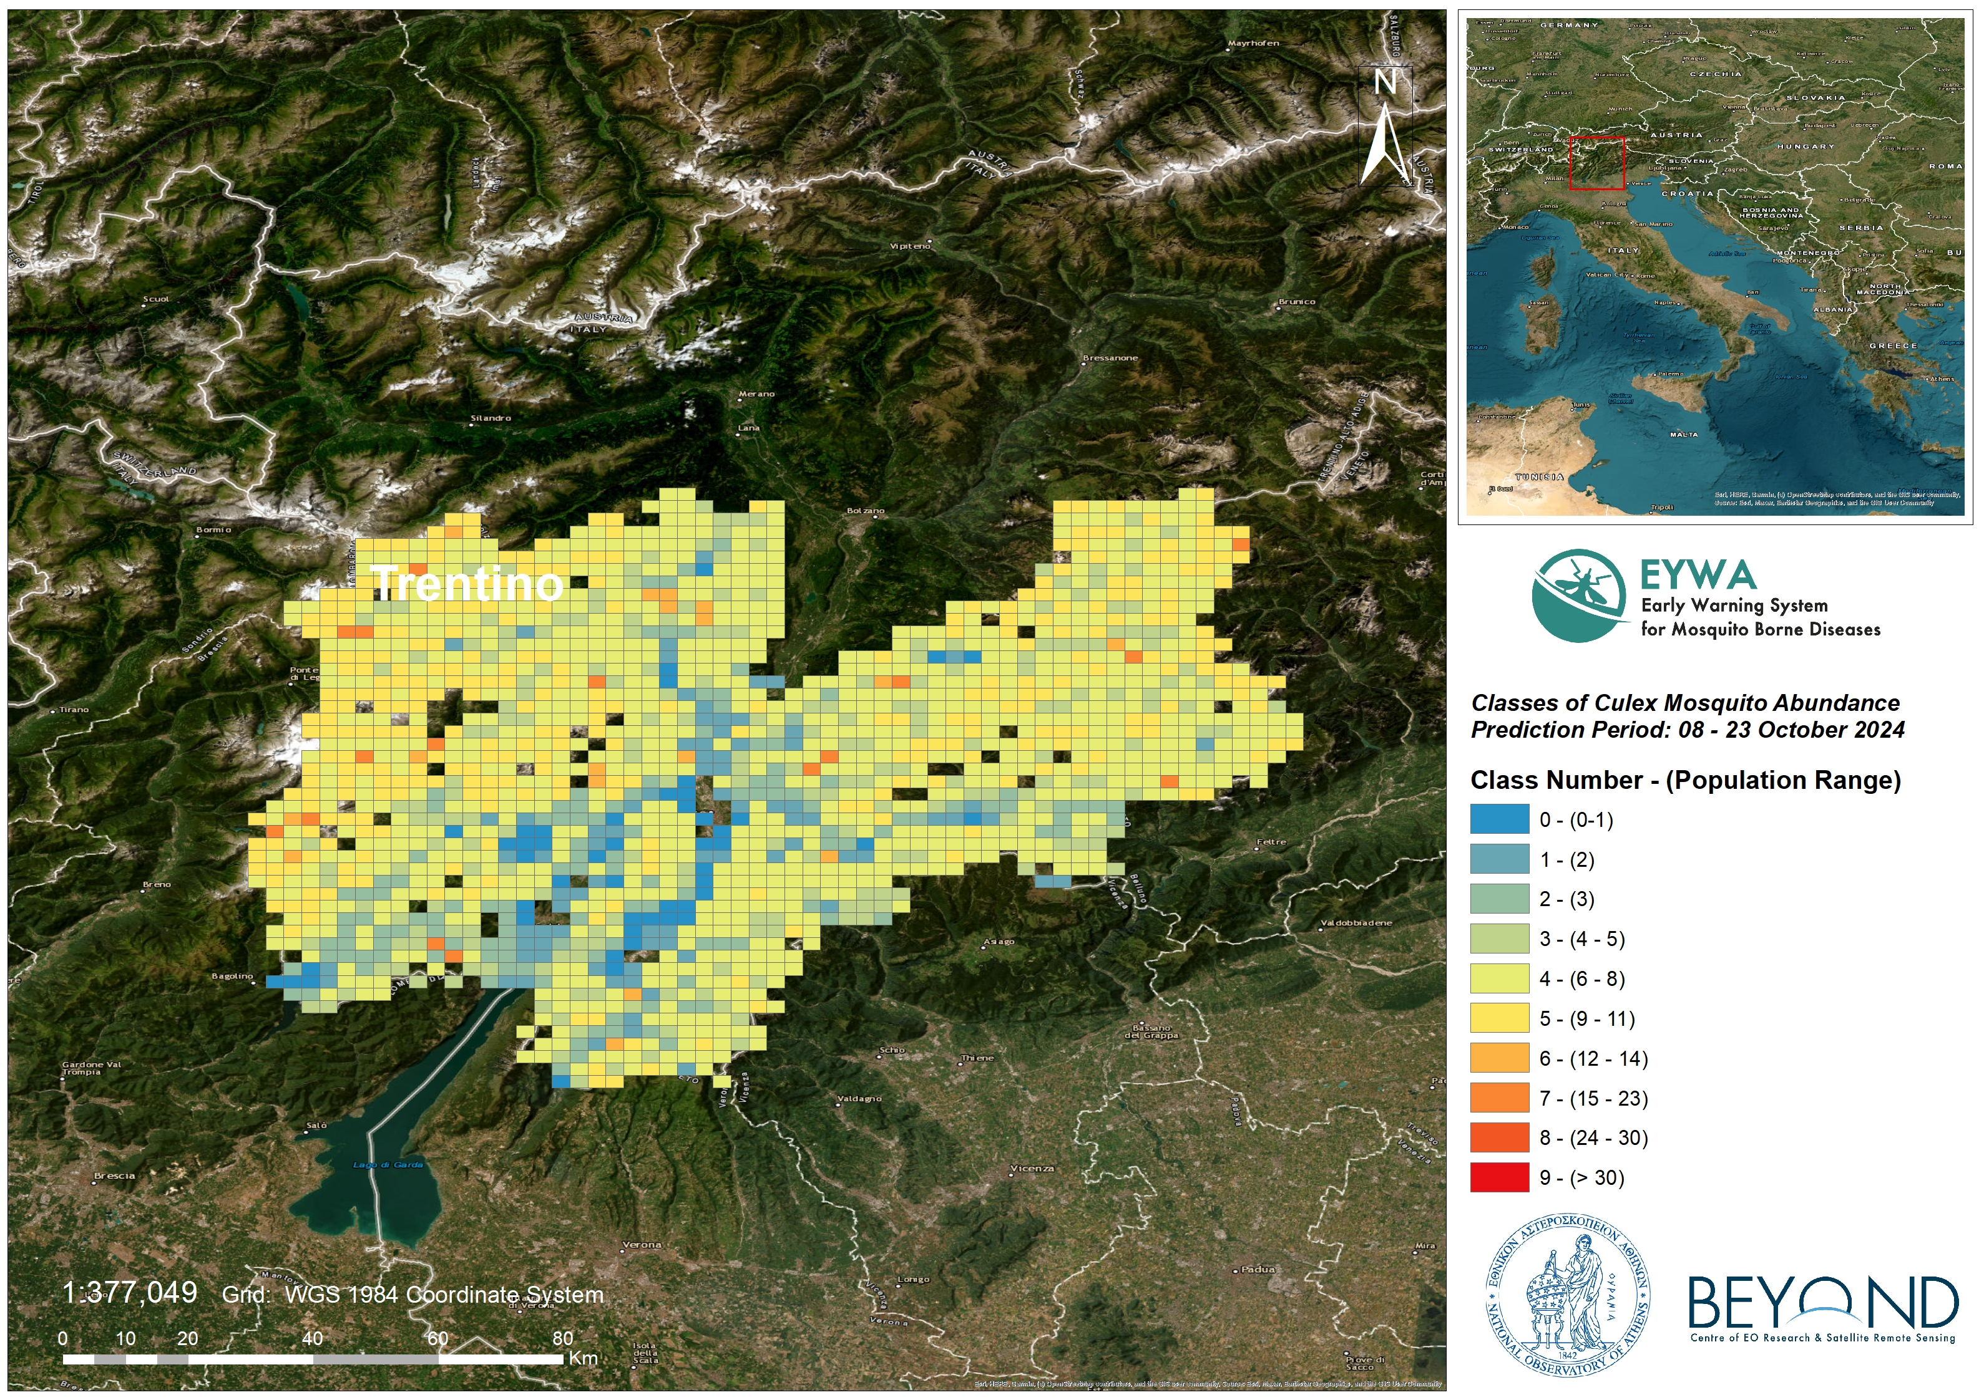

*Figure 3: Culex mosquito abundance at 2x2 km grid in Trentino for October 2024.*

#### B. *Anopheles* mosquitoes’ abundance prediction

The forecast model is based on time series entomological data for the period of 2011-2023. The dataset has been gathered from BG-Sentinel traps, which were used to lure and sample adult mosquitoes from 13 stations distributed among the Trentino region. The data consist of 3724 records and represent the number of mosquitoes, the date of trap placement and date of trap removal.

#### Risk classes

Table 6 shows the classes of the anopheles mosquito abundance and the bounds (range) of mosquito’ numbers per each class.

*Table 6: Bounds of Anopheles mosquito abundance classes*

|  |  |  |
| --- | --- | --- |
| Class | Number of mosquitoes | Risk class |
| 0 | 0 - 1 | low |
| 1 | 2 |
| 2 | 3 | medium |
| 3 | 4 - 5 |
| 4 | 6 - 8 |
| 5 | 9 – 11 |
| 6 | 12 – 14 | high |
| 7 | 15 - 23 |
| 8 | 24 - 40 |
| 9 | > 40 |

#### Reliability of the model

The model has been trained and tested on 10-fold validation data. The trained model outperforms statistically with an expected mean absolute error of **0.04** classes between the actual and the predictive value. Furthermore, the model proves its robustness by capturing the low, medium and high-risk classes of mosquito population with a predictive accuracy of **99.9%.**

#### Prediction

The predictions of the model are presented in the map of, which depicts the predicted trap – stations for October 2024 in the Trentino region ranging from traps colored in blue, stations that the model predicts lower risk class of the *Anopheles* population, to traps colored in red indicating stations with prediction of higher risk class in mosquito abundance. The predictions for October 2024 showed that the stations in the Trentino region will fall into **the low & medium** risk classes ranging from risk class 0 to risk class 2 . In further detail:

* 16602 stations were predicted with risk class 0 & 1 indicating low abundance of mosquitoes (0-2).
* 6 stations were predicted with risk class 2 indicating medium abundance of mosquitoes (3).

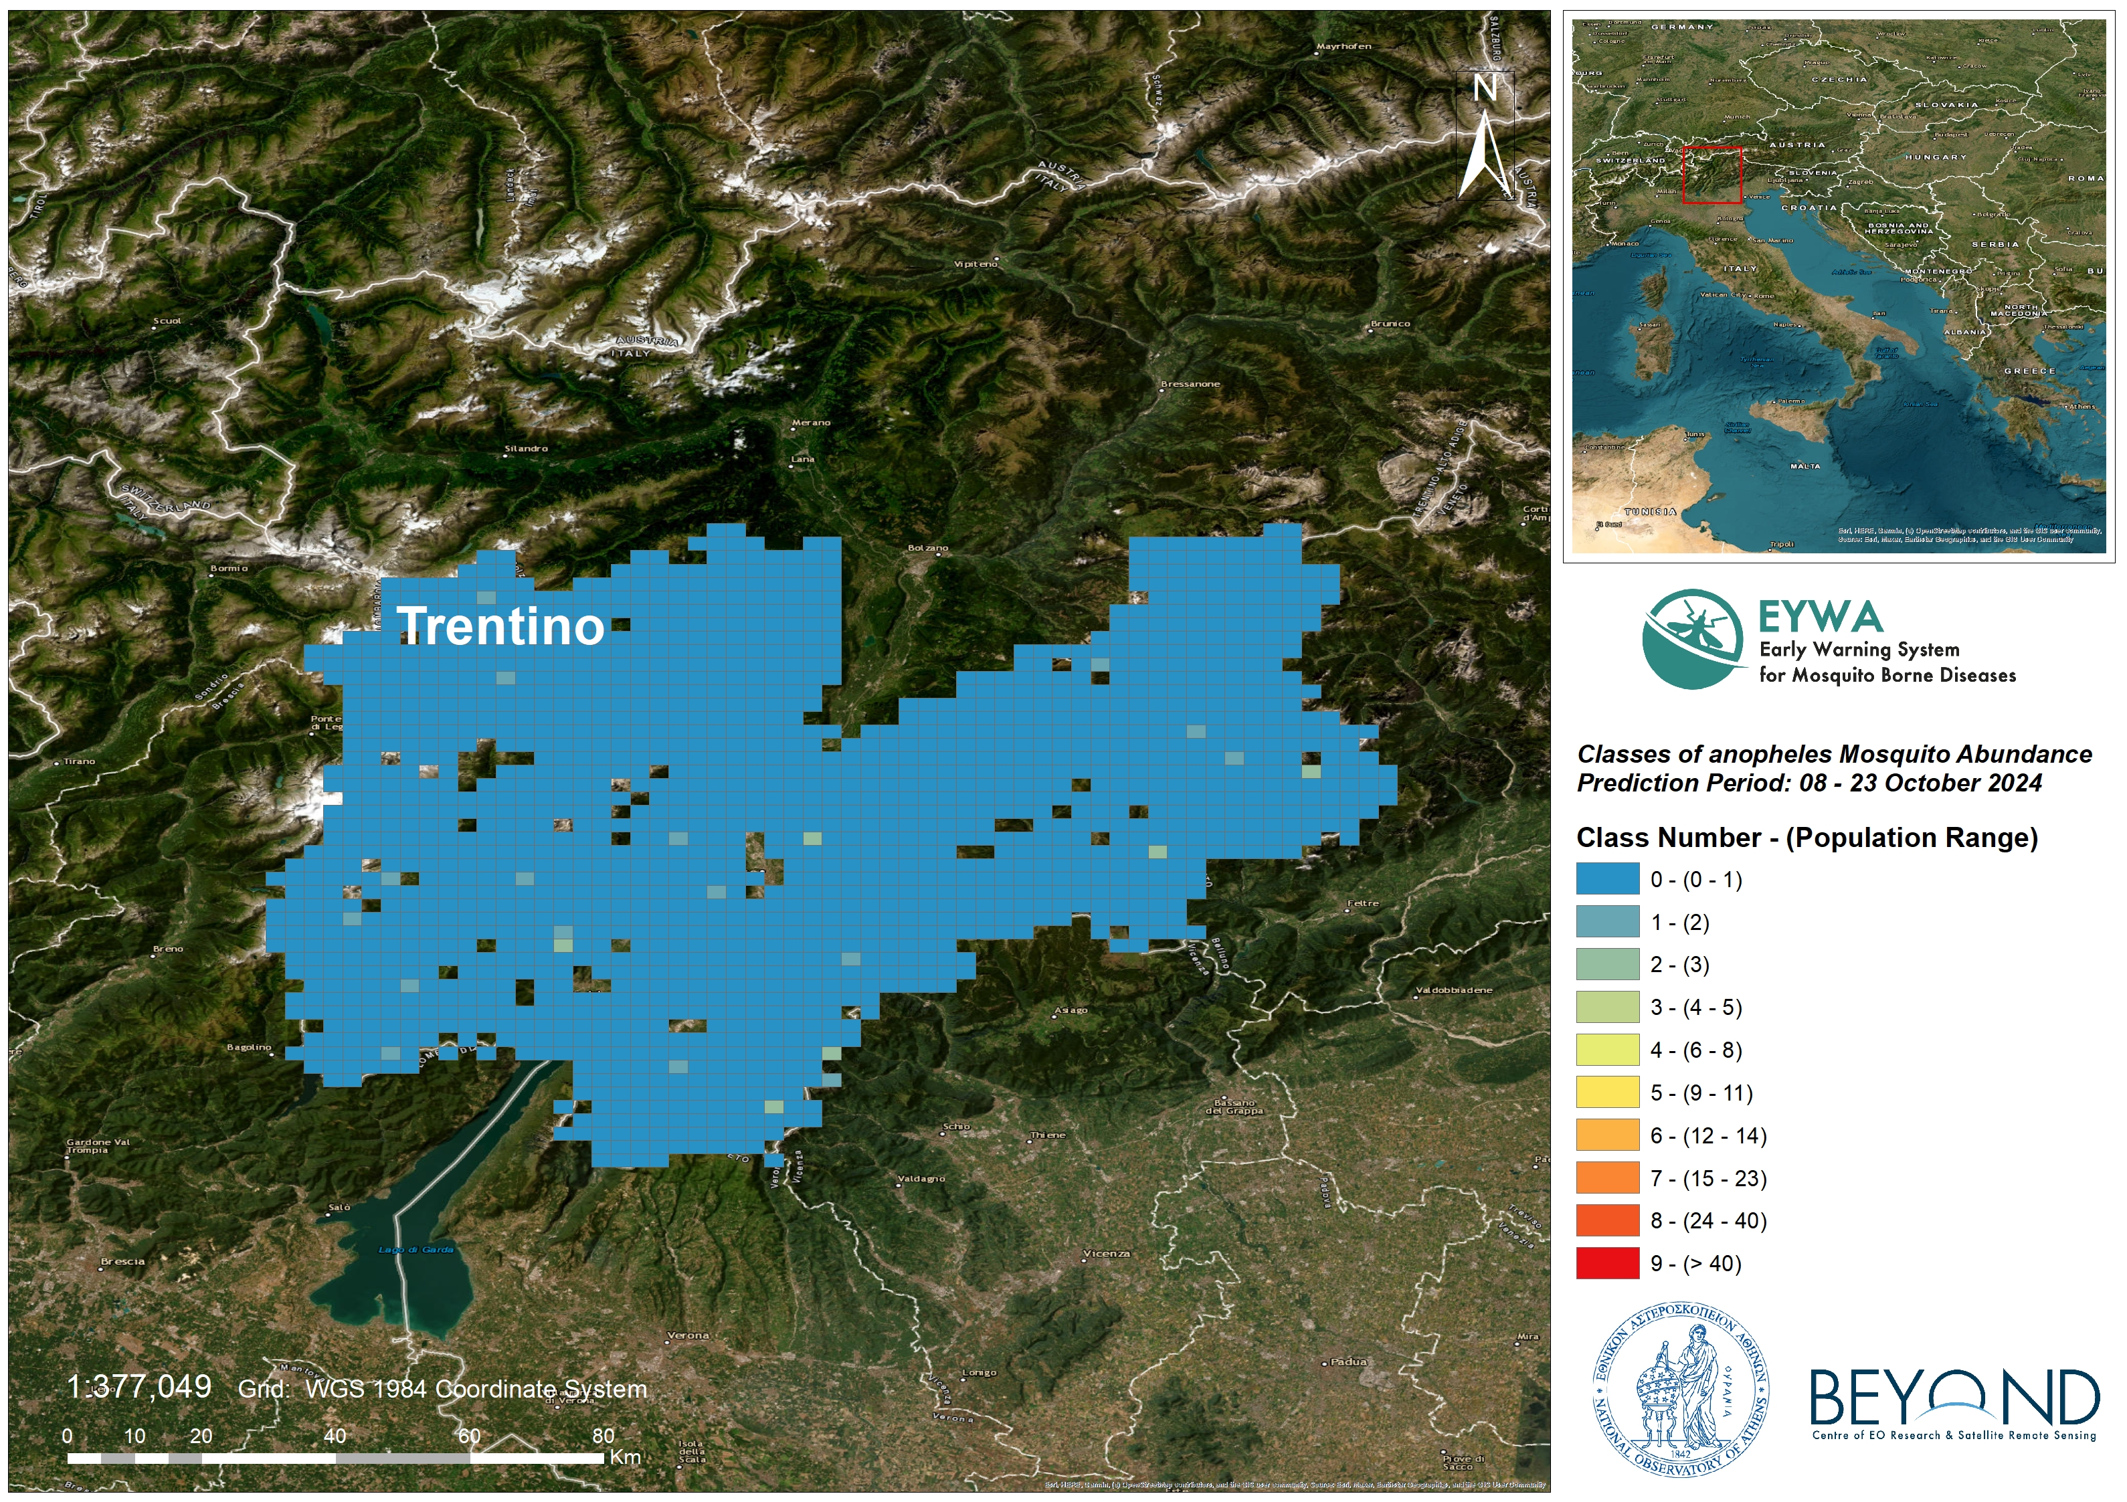

*Figure 4: Anopheles mosquito abundance at 2x2 km grid in Trentino for October 2024.*

#### C. *Aedes Albopictus* mosquitoes’ abundance prediction

The forecast model is based on time series entomological data for the period of 2011-2023. The dataset has been gathered from BG-Sentinel traps, which were used to lure and sample adult mosquitoes from 13 stations distributed among the Trentino region. The data consist of 3878 records and represent the number of mosquitoes, the date of trap placement and date of trap removal.

#### Risk classes

Table 7 shows the classes of the Aedes Albopictus mosquito abundance and the bounds (range) of mosquito’ numbers per each class.

*Table 7: Bounds of Aedes Albopictus mosquito abundance classes*

|  |  |  |
| --- | --- | --- |
| Class | Number of mosquitoes | Risk class |
| 0 | 0 - 1 | low |
| 1 | 2 |
| 2 | 3 | medium |
| 3 | 4 - 5 |
| 4 | 6 - 8 |
| 5 | 9 – 11 |
| 6 | 12 - 14 | high |
| 7 | 15 - 23 |
| 8 | 24 - 40 |
| 9 | > 40 |

#### Reliability of the model

The model has been trained and tested on 10-fold validation data. The trained model outperforms statistically with an expected mean absolute error of **1.26** classes between the actual and the predictive value. Furthermore, the model proves its robustness by capturing the low, medium and high-risk classes of mosquito population with a predictive accuracy of **95%.**

#### Prediction

The predictions of the model are presented in the map of , which depicts the predicted trap – stations for October 2024 in the Trentino region ranging from traps colored in blue, stations that the model predicts lower risk class of the *Aedes Albopictus* population, to traps colored in red indicating stations with prediction of higher risk class in mosquito abundance. The predictions for October 2024 showed that the stations in the Trentino region will fall into **the low, medium & high risk classes,** ranging from risk class 0 to risk class 7. In further detail:

* 659 station was predicted with risk classes 0 - 1 indicating low abundance of mosquitoes (0 - 2).
* 976 stations were predicted with risk classes 2 - 5 indicating medium abundance of mosquitoes (3 - 11).
* 31 stations were predicted with risk classes 6 & 7 indicating high abundance of mosquitoes (12-23).

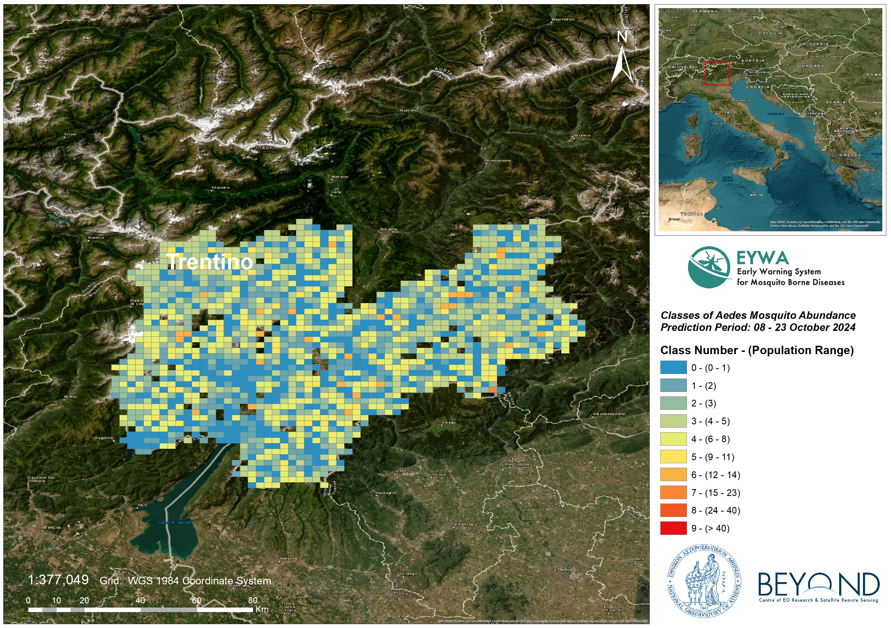

*Figure 5: Aedes Albopictus mosquito abundance at 2x2 km grid in Trentino for October 2024.*

## 2. MIMESIS – Human cases risk model

#### Description

The model simulates dynamically the lifecycle of mosquitoes, birds and humans and the inter specific cycle of WNV between mosquitoes, birds and humans. In total, the model includes 14 health states, dividing the population according to its epidemiological state. The susceptible, exposed, infected, population immune to WNV and dead population, are basic health states. The interface between the 14 compartments occurs through several climatic, demographic, geographical or seasonal dependent parameters. Furthermore, some parameters might have a stochastic value, follow a probability distribution or being constant.

Mathematically, the model is described by 14 differential equations solved arithmetical. The model has been calibrated based on historical simulations of WNV for the period 2008-2023. To produce forecasts, some parameters were estimated using machine learning or ensemble methods.

**Seasonal forecast: Risk maps (seasonal climate forecast init: 1/9/2024)**

|  |  |
| --- | --- |
|  |  |

*Figure 6: (Left) Map of the risk level (RL) of occurrence of WNV human cases in Veneto (*: A human case has been recorded this year), (Right) Map with the month of incidence for WNV human cases in Veneto in the provinces with RL 4 or 5.*

#### Key messages for Veneto:

* The risk level of occurrence of WNV human cases in provinces where no human case has been reported is low (RL<3).
* The estimated total number of human cases in the region is:
  + from 50 to 87 human cases.

#### Intention of the predictions

This Report’s predictions aim to assist National Public Health Authorities and relevant decision makers in:

* organization, resources allocation and strategic design of their mosquito control actions.
* intensification and targeted implementation of entomological and epidemiological surveillance actions.
* information, education and training of citizens on individual mosquito protective measures and actions.

For further information and feedback for the usefulness of the predictions, please contact us at kontoes@noa.gr and +30 210-3490012 (BEYOND Centre of Excellence / National Observatory of Athens).

On behalf of the EYWA project team:

|  |  |  |
| --- | --- | --- |
| **EYWA Project Coordinator**  Dr. Haris Kontoes  Research Director of BEYOND/ NOA  Coordinator of EuroGEO Action Group for Epidemics  Tel: [0030-2103490012](tel:0030-2103490088)  email: kontoes@noa.gr | **University of Patras, Laboratory of Atmospheric Physics (core partner)**  Ioannis Kioutsioukis  Associate Professor | **Collaborating partners’ institutions in Italy**  IZSVe  (Istituto Zooprofilattico Sperimentale delle Venezie)  FEM (Edmund Mach Foundation)  University of Trento/ Department of Mathematics. |